**Objectives:**

Estimate how the stock price of **Ford Company** is ***influenced by* Consumer Credit and Corporate Bond Index.**

**Stationarity Test**

Ensure the variables are stationary and the level of difference of the variables are the same to run VECM.

The difference level for all variables is 1 (according to PP test and ADF test) to make the variables stationary.

**Lag Selection**

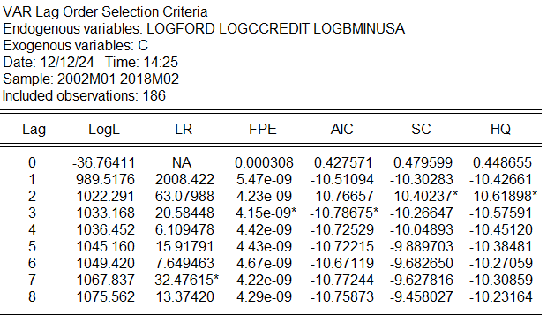

The optimal lag length is 2 (according to SC/BIC and HQ) or 3 (according to AIC) at 5% level.

We would like to choose the parsimonious model, thus, we select lag 2. If the model fails any of the diagnostic test, then, we will select model at lag 3.

**Johansen Cointegration Test**

*Trace Test*

H0: No cointegrating relationship (r=0)

H1: There is cointegrating relationship (r>=1)

Since the p-value = 0.0311 (less than 0.05), we reject the null hypothesis. There is cointegrating relationship.

H0: At most one cointegrating relationship (r<=1)

H1: More than one cointegrating relationship (r>1)

Since p-value is 0.2994 (more than 0.05), we fail to reject null hypothesis. Therefore, there is at most 1 cointegrating relationship.

Conclusion (Trace Test):

There is 1 cointegration equation at the 5% significance level.

*Maximum Eigenvalue*

H0: No cointegrating relationship (r=0)

H1: There is cointegrating relationship (r>=1)

Since the p-value = 0.0404 (less than 0.05), we reject the null hypothesis. There is cointegrating relationship.

H0: At most one cointegrating relationship (r<=1)

H1: More than one cointegrating relationship (r>1)

Since p-value is 0.2300 (greater than 0.05), we fail to reject null hypothesis. Therefore, there is at most 1 cointegrating relationship.

Conclusion (Maximum Eigenvalue):

There is 1 cointegration equation at the 5% significance level.

**Conclusion (Overall):**

* **Both Trace Test and the Maximum Eigenvalue Test indicates there is 1 cointegration equation at 5% significance level.**
* **logford, logccredit and logbminusa share a long-term equilibrium relationship and any deviation from this equilibrium will be corrected over time.**

**Vector Error Correction Model (VECM)**

**

Before interpreting any meaningful observation, we must ensure the model is correctly specified. Thus, diagnostics tests are run on this model.

**Diagnostic Tests**

*Heteroskedasticity Test*

H0: No heteroskedasticity present in the residuals

H1: Heteroskedasticity present in the residuals

The overall (joint) test for heteroskedasticity indicates significant heteroskedasticity in the residuals (p-value = 0.0001 < 0.05, reject null hypothesis)

This may be because one of the individual components (res1*res1) exhibits significant heteroskedasticity based on pairwise chi-squared test and F-test (p-value = 0.0000 < 0.05). This value may influence the overall joint test.

**The residuals from the VECM appear to be heteroskedastic. This means variance of the residuals is not constant across all lags and combinations.**

*Autocorrelation LM Test*

H0: No serial autocorrelation at lag h

H1: There is serial autocorrelation at lag h

Since the p-value at lag 1 and lag 2 is less than 0.05, we reject null hypothesis. Therefore, there is serial autocorrelation at both lags.

H0: No serial autocorrelation at lags 1 through h

H1: Serial autocorrelation at lags 1 through h

When testing for serial correlation across multiple lags (1 to h), lag 2 is not significant (p=0.0609 which is more than 0.05, we fail to reject null hypothesis). Therefore, no evidence of serial correlation when considering joint effects across lags up to 2.

**Since the model fail both diagnostic tests, we must respecify the variables to ensure model is best fit. Autocorrelation in residuals often indicates that the model is missing important dynamics from earlier lags. Adding additional lags can help capture these dynamics and reduce residual autocorrelation.**

**Vector Error Correction Model (VECM)**

At lag 3 (lag interval 1 2) and 1 cointegration equation, VECM is as follow

Before interpreting any meaningful observation, we must ensure the model is correctly specified. Thus, diagnostics tests are run on this model.

**Diagnostic Tests**

*Heteroskedasticity Test*

H0: No heteroskedasticity present in the residuals

H1: Heteroskedasticity present in the residuals

The overall (joint) test for heteroskedasticity indicates significant heteroskedasticity in the residuals (p-value = 0.0000 < 0.05, reject null hypothesis)

This may be because one of the individual components (res1*res1) exhibits significant heteroskedasticity based on pairwise chi-squared test and F-test (p-value = 0.0000 < 0.05). This value may influence the overall joint test.

**The residuals from the VECM appear to be heteroskedastic. This means variance of the residuals is not constant across all lags and combinations.**

*Autocorrelation LM Test*

H0: No serial autocorrelation at lag h

H1: There is serial autocorrelation at lag h

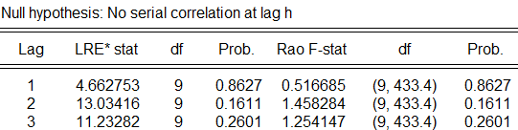

Since the p-value at lag 1, lag 2 and lag 3 is more than 0.05, we fail to reject null hypothesis. Therefore, there is no serial autocorrelation at all lags.

H0: No serial autocorrelation at lags 1 through h

H1: Serial autocorrelation at lags 1 through h

When testing for serial correlation across multiple lags (1 to h), lag 3 is not significant (p=0.4956 which is more than 0.05, we fail to reject null hypothesis). Therefore, no evidence of serial correlation when considering joint effects across lags up to 3.

**Model do not suffer from serial autocorrelation at all lags. However, it is better if the residuals have constant variance over time (homoscedasticity). In this case, it is heteroskedasticity (time-varying variance) instead. However, the model is not necessarily invalid because our objective to identify dynamic interactions of variables which makes heteroscedasticity in residuals not a major issue. Though, we must be careful with our standard error terms.**

**Interpretation for VECM**

At lag 3 (lag interval 1 2) and 1 cointegration equation, VECM is as follow

**The cointegrating equation represents a long-term equilibrium relationship among non-stationary variables. However, we must also take the heteroscedasticity of residuals into account which may make the test statistics unreliable.**

**Xt-1 = (1.096518)Yt-1 + (1.825128)Zt-1 – 6.318302**

**Where,**

**Xt-1 = logford**

**Yt-1 = logccredit**

**Zt-1 = logbminusa**

**Yt-1 :**

* Coefficient: 1.096518 (positive). If logccredit increase by 1%, logford will increase by 1.096518% in the long-term equilibrium. This shows positive elasticity between logccredit and logford.
* Significance: t-statistic = -1.16931 (|t|<1.96, not significant at 5% level). The lack of significance suggests that the variable does not have a stable, long-term equilibrium relationship with logford in the model. It may be less relevant in explaining the long-run dynamics of the system.

**Zt-1 :**

* Coefficient: 1.825128 (positive). If logbminusa increase by 1%, logford will increase by 1.825128% in the long-term equilibrium. This shows positive elasticity between logbminusa and logford.
* Significance: t-statistic = -3.09171 (|t|>1.96, significant at 5% level).

**The CointEq1 represents the error correction term which captures the deviation from the long-term equilibrium. Heteroscedasticity can indirectly affect the cointEq1 coefficient by distorting residual variance and estimation efficiency, potentially leading to a positive coefficient, which happens in this case. This deems interpretation problematic as there is no theoretical proof that disequilibrium diverge with time.**

**For ∆X (first column):**

* Coefficient: -0.022686
* t-statistic: -1.93514 (|t|<1.96, not significant at 5% level)
* Interpretation: any deviation of logford from long-term equilibrium does not significantly adjust to restore its equilibrium.

**For ∆Y (second column):**

* Coefficient: 0.022686
* t-statistic: 3.95930 (|t|>1.96, significant at 5% level)

**For ∆Z (third column):**

* Coefficient: 0.012814
* t-statistic: 1.97737 (|t|>1.96, significant at 5% level)

***Short-Run Dynamic***

**For ∆X (first column):**

Lagged ∆Xt-1 :

* Coefficient: -0.082516
* t-statistic: -1.10824 (|t|<1.96, not significant at 5% level)
* Interpretation: No significant short-term impact of ∆Xt-1 on current ∆X

Lagged ∆Xt-2 :

* Coefficient: 0.011223
* t-statistic: 0.14900 (|t|<1.96, not significant at 5% level)
* Interpretation: No significant short-term impact of ∆Xt-2 on current ∆X

Lagged ∆Yt-1 :

* Coefficient: -0.759475
* t-statistic: -0.51127 (|t|<1.96, not significant at 5% level)
* Interpretation: No significant short-term impact of ∆Yt-1 on current ∆X

Lagged ∆Yt-2 :

* Coefficient: -2.933685
* t-statistic: -1.99685 (|t|>1.96, significant at 5% level)
* Interpretation: Significant short-term impact of ∆Ytwo periods ago on current ∆X. A 1% increase in ∆Yt-2 will decrease ∆X by 293% in short term.

Lagged ∆Zt-1 :

* Coefficient: -0.045348
* t-statistic: -0.33618 (|t|<1.96, not significant at 5% level)
* Interpretation: No significant short-term impact of ∆Zt-1 on current ∆X

Lagged ∆Zt-2 :

* Coefficient: -0.213099
* t-statistic: -1.58722 (|t|<1.96, not significant at 5% level)
* Interpretation: No significant short-term impact of ∆Zt-2 on current ∆X

**For ∆Y (second column):**

Lagged ∆Xt-1 :

* Coefficient: 0.004537
* t-statistic: 1.25023 (|t|<1.96, not significant at 5% level)
* Interpretation: No significant short-term impact of ∆Xt-1 on current ∆Y

Lagged ∆Xt-2 :

* Coefficient: -0.003122
* t-statistic: -0.85040 (|t|<1.96, not significant at 5% level)
* Interpretation: No significant short-term impact of ∆Xt-2 on current ∆Y

Lagged ∆Yt-1 :

* Coefficient: 0.181513
* t-statistic: 2.50694 (|t|>1.96, significant at 5% level)
* Interpretation: Significant short-term impact of ∆Y of one past period on current ∆Y. A 1% increase in ∆Yt-1 will increase ∆Y by 18.15% in short term.

Lagged ∆Yt-2 :

* Coefficient: -0.202599
* t-statistic: -2.83034 (|t|>1.96, significant at 5% level)
* Interpretation: Significant short-term impact of ∆Ytwo periods ago on current ∆Y. A 1% increase in ∆Yt-2 will decrease ∆Y by 20.26% in short term.

Lagged ∆Zt-1 :

* Coefficient: 0.011629
* t-statistic: 1.76865 (|t|<1.96, not significant at 5% level)
* Interpretation: No significant short-term impact of ∆Zt-1 on current ∆Y

Lagged ∆Zt-2 :

* Coefficient: 0.000184
* t-statistic: 0.02816 (|t|<1.96, not significant at 5% level)
* Interpretation: No significant short-term impact of ∆Zt-2 on current ∆Y

**For ∆Z (third column):**

Lagged ∆Xt-1 :

* Coefficient: -0.107743
* t-statistic: -2.61767 (|t|>1.96, significant at 5% level)
* Interpretation: Significant short-term impact of ∆Xt-1 on current ∆Z. A 1% increase in ∆Xt-1 will decrease ∆Z by 10.78% in short term.

Lagged ∆Xt-2 :

* Coefficient: -0.104063
* t-statistic: -2.49909 (|t|>1.96, significant at 5% level)
* Interpretation: Significant short-term impact of ∆Xt-2 on current ∆Z. A 1% increase in ∆Yt-1 will decrease ∆Z by 10.41% in short term.

Lagged ∆Yt-1 :

* Coefficient: -0.463149
* t-statistic: -0.56400 (|t|<1.96, not significant at 5% level)
* Interpretation: No significant short-term impact of ∆Yt-1 on current ∆Z.

Lagged ∆Yt-2 :

* Coefficient: -0.668960
* t-statistic: -0.82400 (|t|<1.96, not significant at 5% level)
* Interpretation: No significant short-term impact of ∆Yt-2 on current ∆Z.

Lagged ∆Zt-1 :

* Coefficient: 0.415140
* t-statistic: 5.56709 (|t|>1.96, significant at 5% level)
* Interpretation: Significant short-term impact of ∆Zt-1 on current ∆Z. A 1% increase in ∆Zt-1 will increase ∆Z by 41.51% in short term.

Lagged ∆Zt-2 :

* Coefficient: -0.033082
* t-statistic: -0.44573 (|t|<1.96, not significant at 5% level)
* Interpretation: No significant short-term impact of ∆Zt-2 on current ∆Y

**Granger-Causality Test**

H0: logccredit does not granger-cause logford.

H1: logccredit granger-cause logford.

p-value is 0.0970 which is greater than 0.05, we fail to reject null hypothesis. logccredit does not granger-cause logford.

H0: logbminusa does not granger-cause logford.

H1: logbminusa granger-cause logford.

p-value is 0.1652 which is greater than 0.05, we fail to reject null hypothesis. logbminusa does not granger-cause logford.

H0: logccredit and logbminusa jointly does not granger-cause logford.

H1: logccredit and logbminusa jointly granger-cause logford.

p-value is 0.0487 which is less than 0.05, we reject null hypothesis. logccredit and logbminusa jointly granger-cause logford.

H0: logford does not granger-cause logccredit.

H1: logford granger-cause logccredit.

p-value is 0.2751 which is greater than 0.05, we fail to reject null hypothesis. logford does not granger-cause logccredit.

H0: logbminusa does not granger-cause logccredit.

H1: logbminusa granger-cause logccredit.

p-value is 0.1541 which is greater than 0.05, we fail to reject null hypothesis. logbminusa does not granger-cause logccredit.

H0: logford and logbminusa jointly does not granger-cause logccredit.

H1: logford and logbminusa jointly granger-cause logccredit.

p-value is 0.1579 which is greater than 0.05, we fail to reject null hypothesis. logford and logbminusa jointly does not granger-cause logccredit.

H0: logford does not granger-cause logbminusa.

H1: logford granger-cause logbminusa.

p-value is 0.0029 which is less than 0.05, we reject null hypothesis. logford granger-cause logbminusa.

H0: logccredit does not granger-cause logbminusa.

H1: logccredit granger-cause logbminusa.

p-value is 0.5589 which is greater than 0.05, we fail to reject null hypothesis. logccredit does not granger-cause logbminusa.

H0: logford and logccredit jointly does not granger-cause logbminusa.

H1: logford and logccredit jointly granger-cause logbminusa.

p-value is 0.0136 which is less than 0.05, we reject null hypothesis. logford and logccredit jointly granger-cause logbminusa. Although, most of the effects is primarily driven by logford.

**Impulse Response Function (IRF)**

We choose to use Generalised Impulse Response Function (GIRF) instead of Orthogonalized Impulse Response Function (Cholesky Decomposition). This is mainly because GIRF does not impose strict ordering on variables (based on no ordering in Granger-Causality test), thus, making GIRF more robust and reliable.

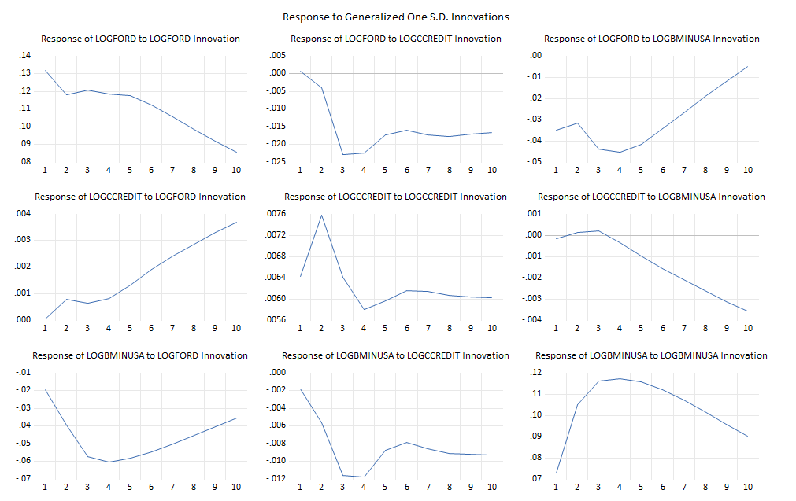

The most substantial and immediate impact on logford comes from its own shock, however, fade as period increases. This indicates the effect of shock is temporary.

It is followed by shocks from logbminusa which has negative short-term effect on logford.

Shocks from logccredit is insignificant and highly negligible as their responses is near zero.

Overall, the pattern suggests that logford is more influenced by its own shocks and by corporate bond index (proxied by logbminusa), with minimal sensitivity to changes in logccredit.

Self-shock in logccredit have the strongest and most immediate impact (period 1), but this effect diminishes quickly. It is followed by the shock from logford which has positive and increasing effect on logccredit. Shocks from logbminusa is insignificant and highly negligible as their responses are near. Overall, the pattern suggests that logccredit is more influenced by its own shocks and followed by logford, with minimal sensitivity to changes in corporate bond index (logbminusa).

logbminusa exhibits strong response to its own shock. logford has small and short-term negative impact on logbminusa (increase then decrease). logccredit has negligible effects with responses fluctuating near zero and shows no clear pattern. Overall, the pattern suggests that logbminusa is more influenced by its own shocks and followed by logford, with minimal sensitivity to changes in logccredit.

**All variables are mostly influenced by its own shocks. logford affects both logccredit and logbminusa albeit temporarily (short-term). logbminusa affects logford and itself only meanwhile logccredit does not affect any other except its own.**

**Variance Decomposition (VD)**

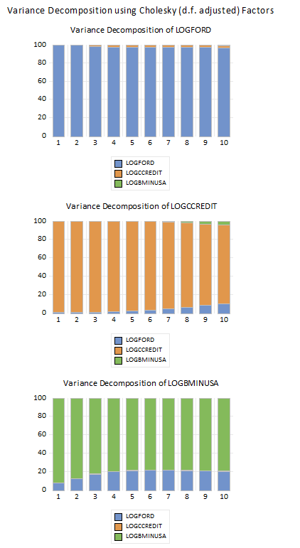

logford variance is dominated by its own shock, with over 90% of the entire forecast variance explained by itself across all periods. logccredit and logbminusa affect logford minimally over period of time.

The majority of logccredit forecast error variance is explained by its own shock. logford contribute significantly towards logccredit variance over time, reflecting a growing influence from this variable. logbminusa also increasingly contribute towards logccredit variance over time.

logbminusa has most of its forecast error variance explained by its own shock initially. However, this self-influence shock decreases over time. logford contribute quite significantly which grows over time, indicating shock from Ford company start to impact the corporate bond index variance as period increases. There is minimal effect from logccredit shocks toward logbminusa variance.